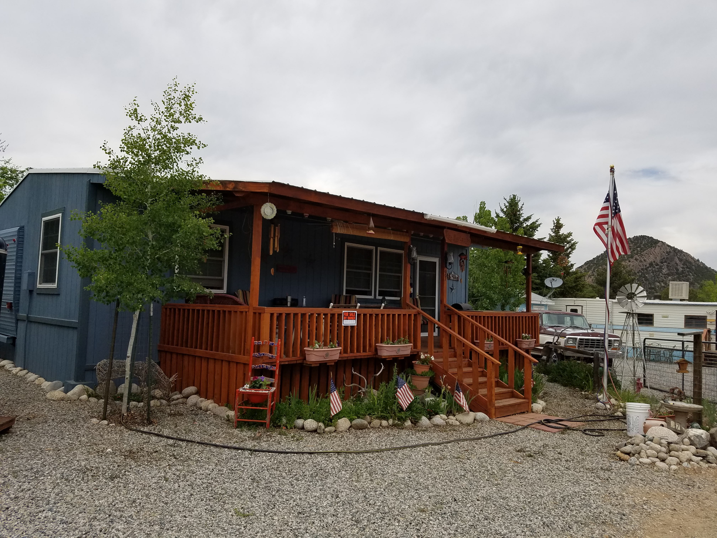ff
For Sale by Owner, Lot 97 $80,000
785-639-3376 or 785-623-1432
Chateau Chaparral
10795 CR 197A
Nathrop, Co.

Sale includes a 1994 International 34 ft. Trailer with a 10’x34 Master BR and Living room addition and redwood deck, completely covered with a metal roof. Along with a shed and a covered parking.

-also included are a small freezer, standard size refrigerator, portable dishwasher and many household furnishings and patio furnishings
-home is set up with a gas fire place, winter water, and completely skirted to make it usable year round
-Chateau Chaparral is a well established HOA community
-Prime Arkansas River frontage with a private bridge access to Brown’s Canyon Monument
-Lot located on Kansas St.
-Large community center with washer, dryers, showers and year round access.

